An organisation dedicated to the Rescue, Rehabilitation and Release of sick or injured birds of prey and to ensure they are cared for by qualified persons and that whenever possible they are released back into the wild.

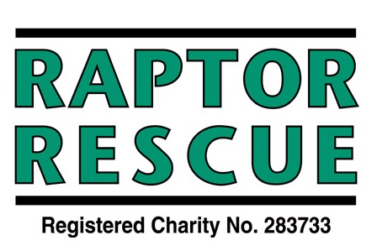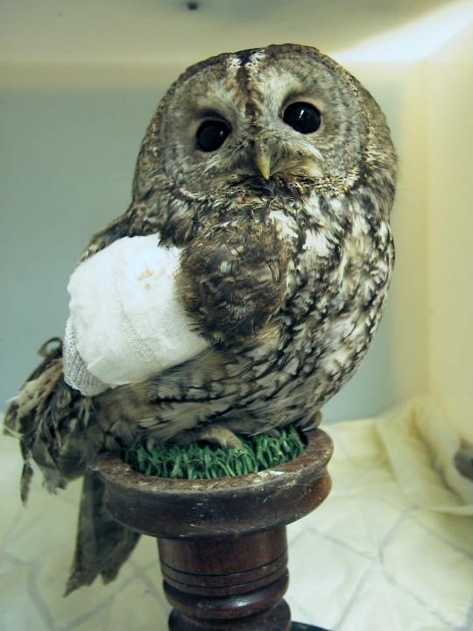

**CAN YOU HELP!**

Raptor Rescue is always looking for volunteers to help rehabilitating birds of prey, collecting birds of prey, fundraising and helping at events.

If you would like to get involved and can spare some time or would like more information on any of our activities, please tick the box(s) below you are interested in, fill in your name and address and return to the address below.

Rehabilitator Bird Collecting

Fundraising Helping at Events

Name:

Address:

Telephone:

E-mail:

**Return to:** [**secretary@raptorrescue.org.uk**](mailto:secretary@raptorrescue.org.uk)

**www.raptorrescue.org.uk**